Lesson 2: Reference Frames
MECH 637: Astrodynamic Reentry
Fall 2022
Lt Col Robert A. Bettinger, Ph.D  Office: Bldg 640, Room 345-F | E-mail: Robert.Bettinger@afit.edu  Phone: 937-255-3636 x4578

Geocentric-Equatorial Coordinate Frame
- Frame notation: $OXYZ$
- Inertial reference frame with origin at planetary center
- $x$-axis $\left({\hat{e}}_{x}\right)$: Points in direction of the Vernal Equinox
- $z$-axis $\left({\hat{e}}_{z}\right)$: Points in direction of the North Pole
- $y$-axis $\left({\hat{e}}_{y}\right)$: Orthogonal to the $x$-, $z$-axes; lies in the equatorial plane: ${\hat{e}}_{z}={\hat{e}}_{x}×{\hat{e}}_{y}$
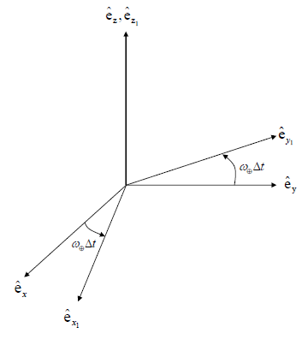
Planet-Fixed Coordinate Frame
- Frame notation: $OX_{1}Y_{1}Z_{1}$
- Planet-fixed reference frame with origin at planetary center
- $z_{1}$-axis $\left({\hat{e}}_{z_{1}}\right)$: Points in direction of the North Pole
- $x_{1},y_{1}$ plane coincident with equatorial plane
- Assume planet rotates with a constant velocity: ${\overset{⃑}{ω}}_{⨁}=ω_{⨁}{\hat{e}}_{z_{1}}=ω_{⨁}{\hat{e}}_{z}$
- Coordinate transformation, where$\hat{e}$ and ${\hat{e}}_{1}$ represent the unit vectors of the $OXYZ$ and $OX_{1}Y_{1}Z_{1}$ frames, respectively:
$$\left[{\hat{e}}_{1}\right]=\left[\begin{matrix}\cos\left(ω_{⨁}∆t\right) & \sin\left(ω_{⨁}∆t\right) & 0 \\ -\sin\left(ω_{⨁}∆t\right) & \cos\left(ω_{⨁}∆t\right) & 0 \\ 0 & 0 & 1\end{matrix}\right]\left[\hat{e}\right] \\ =R_{z}\left(ω_{⨁}∆t\right)\left[\hat{e}\right]$$
Where $R_{z}$ represents the rotation matrix about the $z$-axis.
Vehicle-Pointing Coordinate Frame
- Frame notation: $OX_{2}Y_{2}Z_{2}$
- Origin at planetary center
- $x_{2}$-axis $\left({\hat{e}}_{x_{2}}\right)$: Points along vehicle’s position vector
- $y_{2}$-axis $\left({\hat{e}}_{y_{2}}\right)$: Parallel to equatorial plane
- $z_{2}$-axis $\left({\hat{e}}_{z_{2}}\right)$: Orthogonal to the $x_{2}$-, $y_{2}$-axes and completes right-handed system
- Coordinate transformation, where${\hat{e}}_{1}$ and ${\hat{e}}_{2}$ represent the unit vectors of the $OX_{1}Y_{1}Z_{1}$ and $OX_{2}Y_{2}Z_{2}$ frames, respectively:
$$\left[{\hat{e}}_{2}\right]=\left[\begin{matrix}\cos\left(-ϕ\right) & 0 & -\sin\left(-ϕ\right) \\ 0 & 1 & 0 \\ \sin\left(-ϕ\right) & 0 & \cos\left(-ϕ\right)\end{matrix}\right]\left[\begin{matrix}\cos{θ} & \sin{θ} & 0 \\ -\sin{θ} & \cos{θ} & 0 \\ 0 & 0 & 1\end{matrix}\right]\left[{\hat{e}}_{1}\right] \\ =\left[\begin{matrix}\cos{ϕ}\cos{θ} & \cos{ϕ}\sin{θ} & \sin{ϕ} \\ -\sin{θ} & \cos{θ} & 0 \\ -\sin{ϕ}\cos{θ} & -\sin{ϕ}\sin{θ} & \cos{ϕ}\end{matrix}\right]\left[{\hat{e}}_{1}\right]=R_{y_{2}}\left(-ϕ\right)R_{z_{1}}\left(θ\right)\left[{\hat{e}}_{1}\right]$$
Where $θ$ is longitude and $ϕ$ is latitude. Note: Coordinate transformation is accomplished by first multiplying ${\hat{e}}_{1}$ by $R_{z_{1}}\left(θ\right)$, then the result by $R_{y_{2}}\left(-ϕ\right)$.
- Coordinate transformation, where$\hat{e}$ and ${\hat{e}}_{2}$ represent the unit vectors of the $OXYZ$ and $OX_{2}Y_{2}Z_{2}$ frames, respectively:
$$\left[{\hat{e}}_{2}\right]=R_{y_{2}}\left(-ϕ\right)R_{z_{1}}\left(θ\right)R_{z}\left(ω_{⨁}∆t\right)\left[\hat{e}\right]$$
- Flight-Path Angle $\left(γ\right)$: The angle between the local horizontal frame (i.e., the plane passing through the vehicle and orthogonal to $\overset{⃑}{r}$) and the velocity $\overset{⃑}{v}$
  - $γ$ is positive when $\overset{⃑}{v}$ is above the local horizontal plane
  - $γ$ describes how much the velocity vector contributes to moving “in and out” along the radial vector
- Heading Angle $\left(ψ\right)$: The angle between the local parallel of latitude and the projection of $\overset{⃑}{v}$ onto the local horizontal plane
  - $ψ$ is positive in the right-handed direction about the $x_{2}$-axis
  - $ψ$ describes how much the velocity vector contributes to moving “toward and away” from the equatorial plane
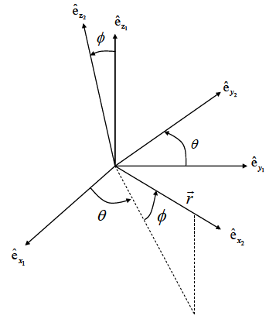 | 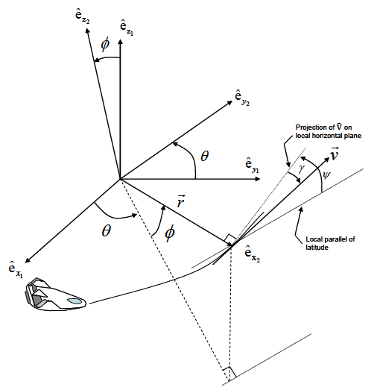
Velocity-Referenced Coordinate Frame
- Frame notation: $OX''Y''Z''$
- Step 1: Create $OX'Y'Z'$ by rotating the $OX_{2}Y_{2}Z_{2}$ frame about the $x_{2}$-axis by $ψ$ so that the “new” $y$-axis, $y'$, is aligned with the projection of $\overset{⃑}{v}$ on the local horizontal plane:
$$\left[\begin{matrix}{\hat{e}}_{x}^{'} \\ {\hat{e}}_{y}^{'} \\ {\hat{e}}_{z}^{'}\end{matrix}\right]=\left[\begin{matrix}{\hat{e}}_{x_{2}} \\ {\hat{e}}_{y}^{'} \\ {\hat{e}}_{z}^{'}\end{matrix}\right]=\left[\begin{matrix}1 & 0 & 0 \\ 0 & \cos{ψ} & \sin{ψ} \\ 0 & -\sin{ψ} & \cos{ψ}\end{matrix}\right]\left[\begin{matrix}{\hat{e}}_{x_{2}} \\ {\hat{e}}_{y_{2}} \\ {\hat{e}}_{z_{2}}\end{matrix}\right]$$
$$\left[{\hat{e}}^{'}\right]=R_{x_{2}}\left(ψ\right)\left[{\hat{e}}_{2}\right]$$
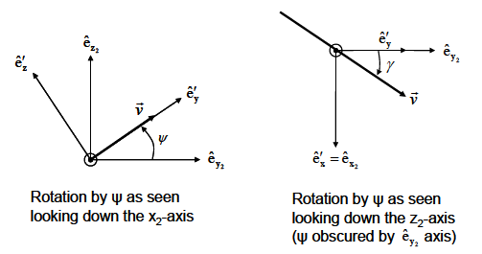
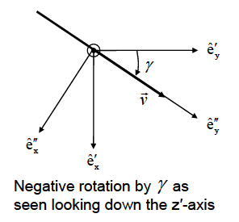
- Step 2: Negatively rotate the $OX'Y'Z'$ frame about the $z'$-axis by $γ$ so that the “new” $y$-axis, $y''$, is aligned with $\overset{⃑}{v}$:
$$\left[\begin{matrix}{\hat{e}}_{x}^{''} \\ {\hat{e}}_{y}^{''} \\ {\hat{e}}_{z}^{''}\end{matrix}\right]=\left[\begin{matrix}{\hat{e}}_{x}^{''} \\ {\hat{e}}_{y}^{''} \\ {\hat{e}}_{z}^{'}\end{matrix}\right]=\left[\begin{matrix}\cos\left(-γ\right) & \sin\left(-γ\right) & 0 \\ -\sin\left(-γ\right) & \cos\left(-γ\right) & 0 \\ 0 & 0 & 1\end{matrix}\right]\left[\begin{matrix}{\hat{e}}_{x}^{'} \\ {\hat{e}}_{y}^{'} \\ {\hat{e}}_{z}^{'}\end{matrix}\right] \\ \left[\begin{matrix}{\hat{e}}_{x}^{''} \\ {\hat{e}}_{y}^{''} \\ {\hat{e}}_{z}^{''}\end{matrix}\right]=\left[\begin{matrix}{\hat{e}}_{x}^{''} \\ {\hat{e}}_{y}^{''} \\ {\hat{e}}_{z}^{'}\end{matrix}\right]=\left[\begin{matrix}\cos{γ} & -\sin{γ} & 0 \\ \sin{γ} & \cos{γ} & 0 \\ 0 & 0 & 1\end{matrix}\right]\left[\begin{matrix}{\hat{e}}_{x}^{'} \\ {\hat{e}}_{y}^{'} \\ {\hat{e}}_{z}^{'}\end{matrix}\right]$$
$$\left[{\hat{e}}^{''}\right]=R_{z^{'}}\left(-γ\right)\left[{\hat{e}}^{'}\right]$$
- Final coordinate transformation:
$$\left[\begin{matrix}{\hat{e}}_{x}^{''} \\ {\hat{e}}_{y}^{''} \\ {\hat{e}}_{z}^{''}\end{matrix}\right]=\left[\begin{matrix}\cos{γ} & -\sin{γ}\cos{ψ} & -\sin{γ}\sin{ψ} \\ \sin{γ} & \cos{γ}\cos{ψ} & \cos{γ}\sin{ψ} \\ 0 & -\sin{ψ} & \cos{ψ}\end{matrix}\right]\left[\begin{matrix}{\hat{e}}_{x_{2}} \\ {\hat{e}}_{y_{2}} \\ {\hat{e}}_{z_{2}}\end{matrix}\right]$$
$$\left[{\hat{e}}^{''}\right]=R_{z^{'}}\left(-γ\right)R_{x_{2}}\left(ψ\right)\left[{\hat{e}}_{2}\right]$$
  - ${\hat{e}}_{y}^{''}$-axis: Points along the velocity vector $\overset{⃑}{v}$; equivalently denoted as ${\hat{e}}_{v}$
  - ${\hat{e}}_{z}^{''}$-axis: Perpendicular to both the velocity $\overset{⃑}{v}$ and radial $\overset{⃑}{r}$ vectors, and lies in the local horizontal plane
Relative Angular Motion
- Angular rotation is terms of the$OX_{1}Y_{1}Z_{1}$ and $OXYZ$ frames, respectively:
$${\overset{⃑}{ω}}_{⨁}=ω_{⨁}{\hat{e}}_{z_{1}}=ω_{⨁}{\hat{e}}_{z}$$
Recall the transformation from the $OX_{1}Y_{1}Z_{1}$ to the $OX_{2}Y_{2}Z_{2}$ frame:
$$\left[{\hat{e}}_{2}\right]=\left[\begin{matrix}\cos{ϕ}\cos{θ} & \cos{ϕ}\sin{θ} & \sin{ϕ} \\ -\sin{θ} & \cos{θ} & 0 \\ -\sin{ϕ}\cos{θ} & -\sin{ϕ}\sin{θ} & \cos{ϕ}\end{matrix}\right]\left[{\hat{e}}_{1}\right]$$
$${\left[\overset{⃑}{ω}\right]}_{1/0}^{{\hat{e}}_{2}}=\left[\begin{matrix}\cos{ϕ}\cos{θ} & \cos{ϕ}\sin{θ} & \sin{ϕ} \\ -\sin{θ} & \cos{θ} & 0 \\ -\sin{ϕ}\cos{θ} & -\sin{ϕ}\sin{θ} & \cos{ϕ}\end{matrix}\right]\left[\begin{matrix}0 \\ 0 \\ ω_{⨁}\end{matrix}\right]$$
$${\overset{⃑}{ω}}_{⨁}={\left[\overset{⃑}{ω}\right]}_{1/0}^{{\hat{e}}_{2}}=\left(ω_{⨁}\sin{ϕ}\right){\hat{e}}_{x_{2}}+\left(ω_{⨁}\cos{ϕ}\right){\hat{e}}_{z_{2}}$$
Note: ${\left[\overset{⃑}{ω}\right]}_{1/0}^{{\hat{e}}_{2}}$ indicates that the angular rate of $OX_{1}Y_{1}Z_{1}$ relative to $OXYZ$ is written in terms of coordinates along the $\left[{\hat{e}}_{2}\right]$ unit vectors.
- An equation for the overall angular rate can be assembled according to the transformation to $\left[{\hat{e}}_{2}\right]$ from $\left[{\hat{e}}_{1}\right]$ unit vectors:
$$\overset{⃑}{Ω}=\dot{θ}{\hat{e}}_{z_{1}}-\dot{ϕ}{\hat{e}}_{y_{2}}$$
When expressed entirely in the vehicle-pointing frame, the preceding equation becomes:
$${\left[\overset{⃑}{Ω}\right]}_{2/1}^{{\hat{e}}_{2}}=\overset{⃑}{Ω}=\left(\dot{θ}\sin{ϕ}\right){\hat{e}}_{x_{2}}-\dot{ϕ}{\hat{e}}_{y_{2}}+\left(\dot{θ}\cos{ϕ}\right){\hat{e}}_{z_{2}}$$

Source Consulted
Hicks, Kerry D. Introduction to Astrodynamic Reentry, Second Edition. Dayton, OH: Hicks, 2014.

